You are given the root of a binary tree with **unique** values, and an integer start. At minute 0, an **infection** starts from the node with value start.

Each minute, a node becomes infected if:

* The node is currently uninfected.
* The node is adjacent to an infected node.

Return *the number of minutes needed for the entire tree to be infected.*

**Example 1:**

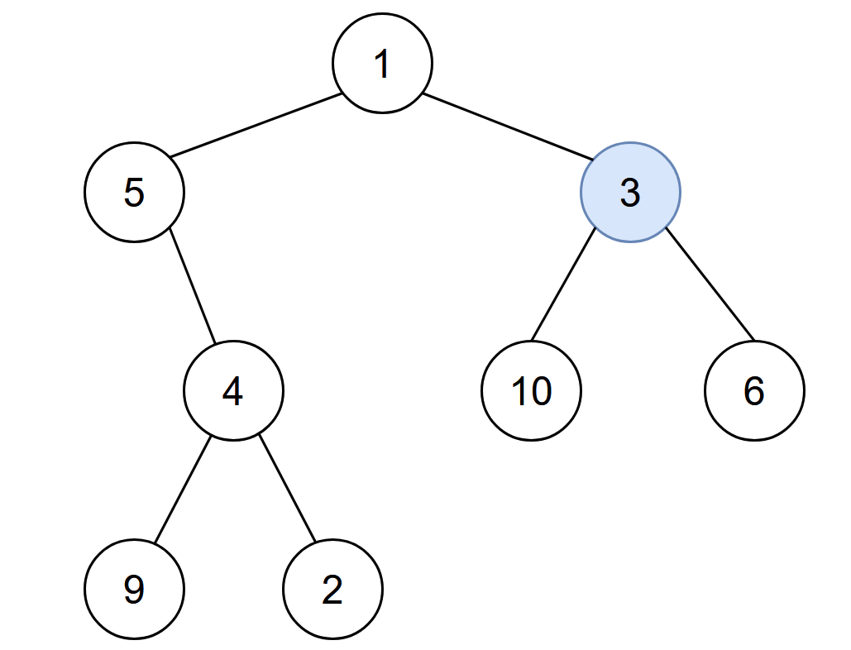

Input: root = [1,5,3,null,4,10,6,9,2], start = 3  
Output: 4  
Explanation: The following nodes are infected during:  
- Minute 0: Node 3  
- Minute 1: Nodes 1, 10 and 6  
- Minute 2: Node 5  
- Minute 3: Node 4  
- Minute 4: Nodes 9 and 2  
It takes 4 minutes for the whole tree to be infected so we return 4.

**Example 2:**



Input: root = [1], start = 1  
Output: 0  
Explanation: At minute 0, the only node in the tree is infected so we return 0.

**Constraints:**

* The number of nodes in the tree is in the range [1, 105].
* 1 <= Node.val <= 105
* Each node has a **unique** value.
* A node with a value of start exists in the tree.